Network components

Network infrastructure

Path of a message can be as simple as a single cable connecting 2 computers, or as complex as a network that literally spams the globe

**This network infrastructure is the platform that supports the network. It provides stable and reliable channel over which our communications can occur**

It contains three categories of hardware components:  
 - end devices

- intermediate devices

- network media

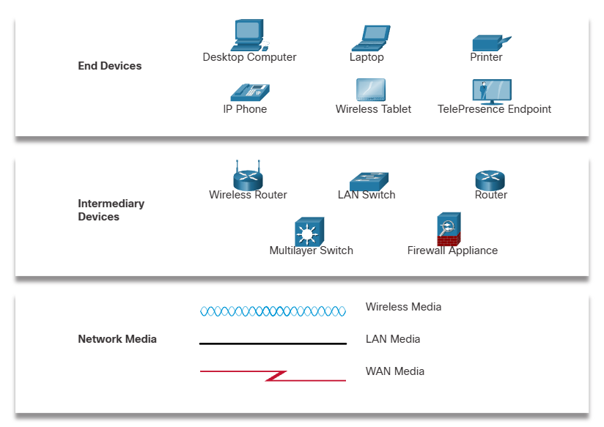

Devices and media are the physical elements, or hardware of network

Its often the visible part of the network (PC, laptop, switch, router, wireless access point)

End devices

**The network devices peole are most familiar with are called end devices, or host**

Some examples:  
 computers  
 network printers

Telephones

Security cameras

Mobile devices…

**Its either source or destination of message transmitted over the network**

**To identify host adresses are used**